Now that we're working with PHP, we will need to be able to upload our files to a server in order to test them out. You can either install an Apache server locally, or use a web host. For in-class work, I have an FTP account students can use to test out their work. You will get an email on how to log in.

The login information will include: FTP URL, Username, and Password.

The lab computers at UMKC have Filezilla, but it is also a cross-platform program you can download on your own machine. If you have a favorite FTP client feel free to use that.

First, let's create a simple index.php page. Add the following code:

<!DOCTYPE html>
<html>
<head>
<title>Sample</title>
</head>

<body>
<p>
Today's date is:
<?=date( "Y-m-d" )?>
</p>
</body>
</html>

Now, open Filezilla. Cilck on the top-left icon to open up the Site Manager.

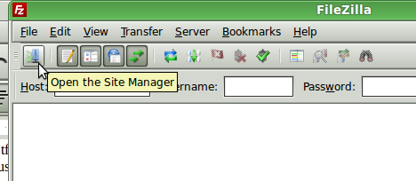

Click on the “New Site” button and type in a name for this site (this is an arbitrary name, just to remind you what it is).

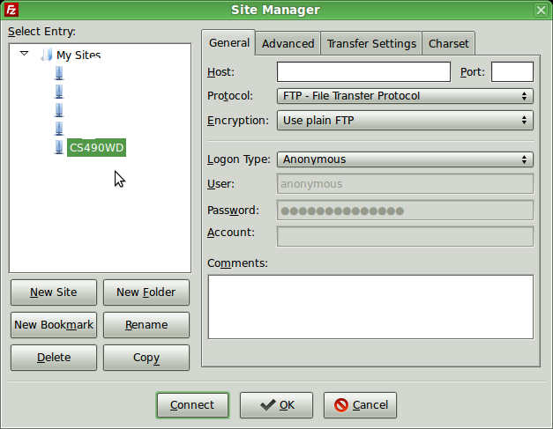
Under Host, paste in the FTP URL from the email.
Next, click on the Logon Type dropdown box. Select Normal. This will allow you to fill out the User and Password fields.

Use the username and password provided in the email. When you're done, click “Connect”.

The FTP client is split into two sides – The left side is your local hard-drive. The right side is the server.

Create a new folder on the server for yourself by right-clicking in the empty space and selecting “Create directory”.

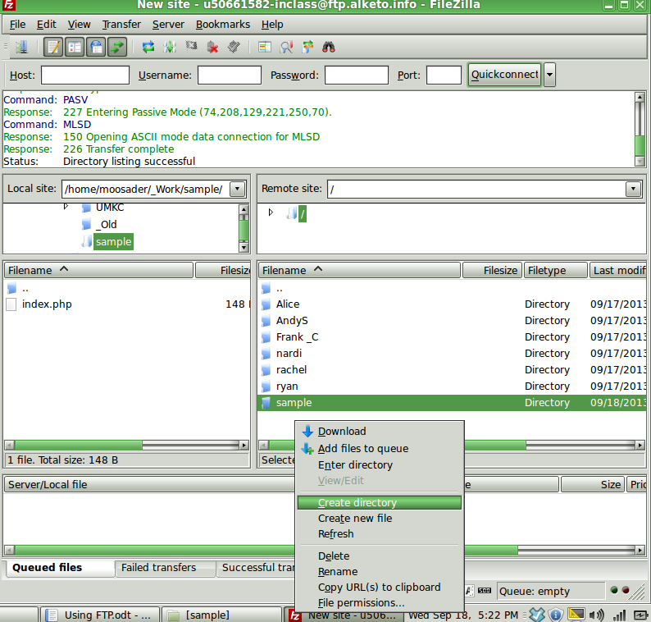
Open up the folder. Move your index.php file from the left side to the right side by clicking and dragging. Now your index file is uploaded to the server.

Note that if you have an index.html or index.php file in a directory, it will be the default file opened when you navigate to that path on the URL.

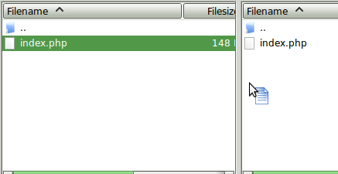

After the file is uploaded, you can go to http://www.alketo.info/inclass/sample/yourfolder

You should get a blank page that says:
Today's date is: 2013-09-18

You can use this server for your in-class projects. If your team needs webspace for your group project, please email me so I can set you up a separate space.

